# SUBSCRIBERS GALORE EXPLOERING WORLD’S TOP YOUTUBE CHANNELS

# 1.Introdution:

## 1. Keep in mind that Youtube’s landscape is ever-evolving, and new channels may have risen to prominence since my last update.

## 2. You can explore these channels on You Tube to discover their latest content and check their curennt subscriber counts.

## 1.1. OVERVIEW:

## As of my last knowledge update in september 2021, I can provide you with an overview of some of the top channels.

## Please keep in mind that Youtube ranking can change rapidly due to shifts in viewership and subscriptions.

## For the most current Information, consider checking you tuber’s official statistics or third-party tracking websites.

## 1.2. purpose:

## The You Tube channels serve various purposes and cater to a wide range of audiences.

## 

## Here are some common purposes of the world’s top you Tube channels.

## These are just a few examples of the diverse purpose that Top You Tube channels serve .

## 2. problem defining & Design ThinkingL:

## Defining a problem and applying design thinking to address ir can be a valuable approach for You Tube channels looking to improve or grow their content and audience.

## Here’s how you can apply problem definition and design thinking to top You Tube channels.

## 3.By following these steps and maintain a user ventric approach you tube channels can address problems, enhance their content, and better connect with their target audience,ultimately leading to growth and success.

## 2.1.EMPATHY MAP:

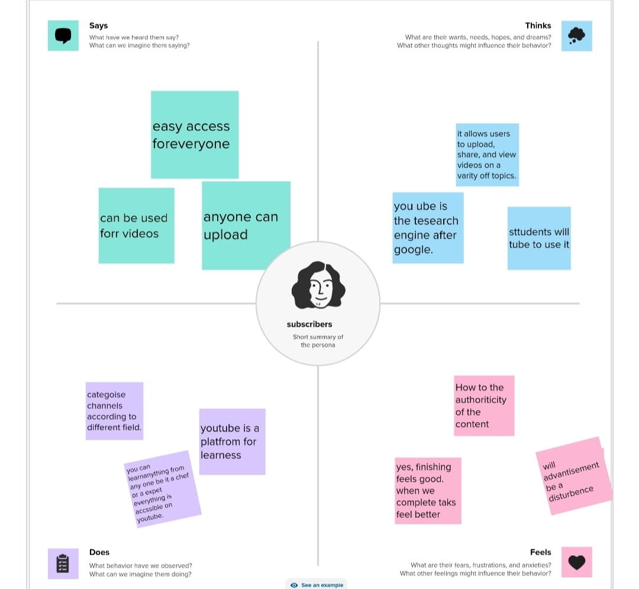

## 2.2 BRAINSTROMING

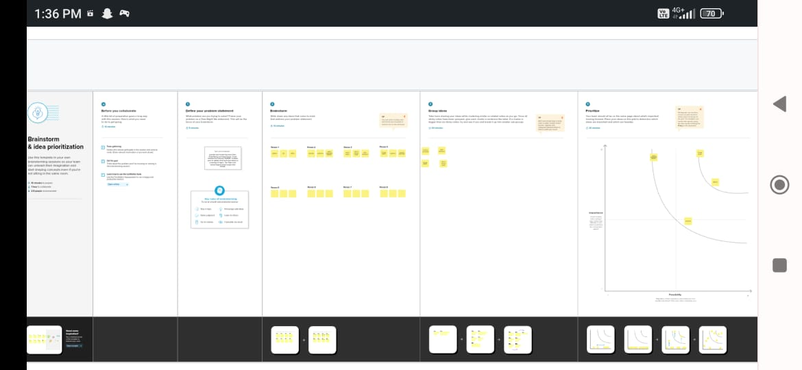

## 3.RESULTS C:\Users\NAGARAJ\Downloads\WhatsApp Image 2023-10-13 at 8.04.12 PM (3).jpeg

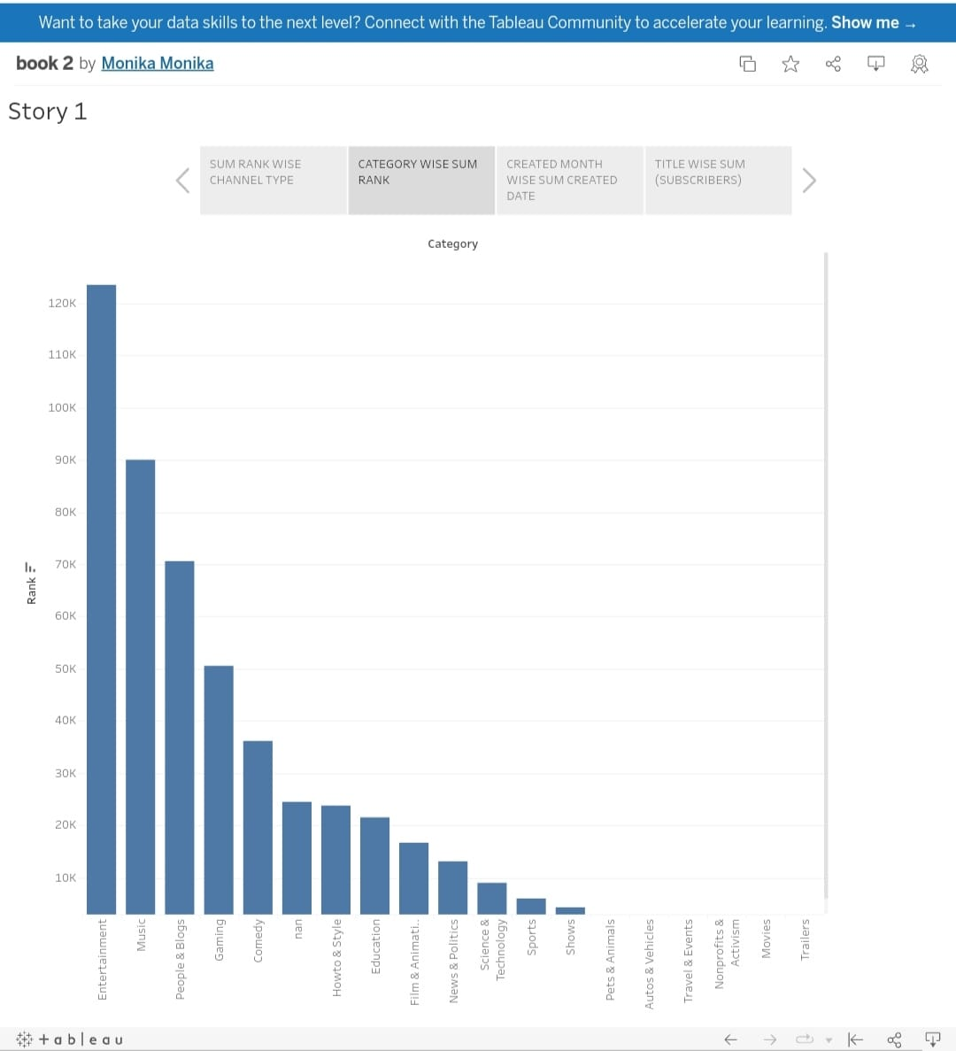

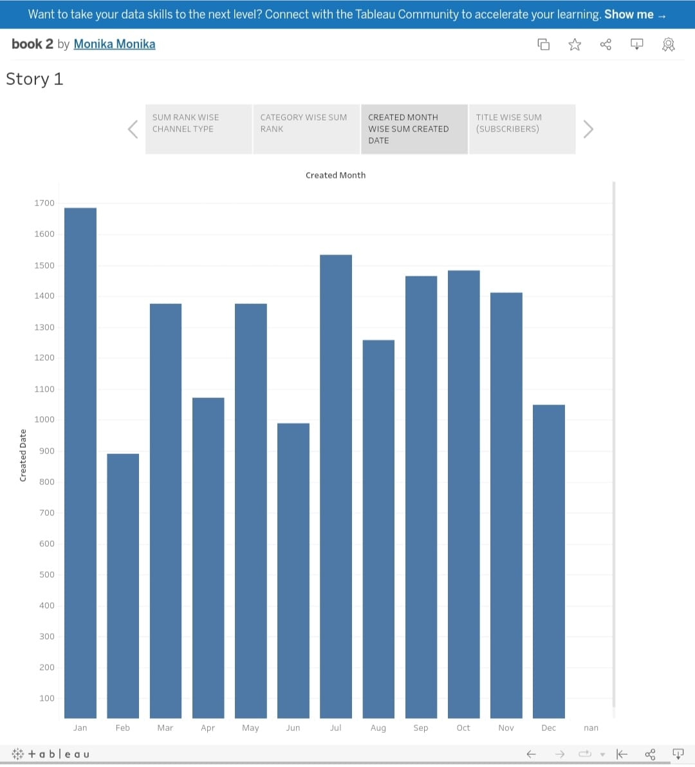

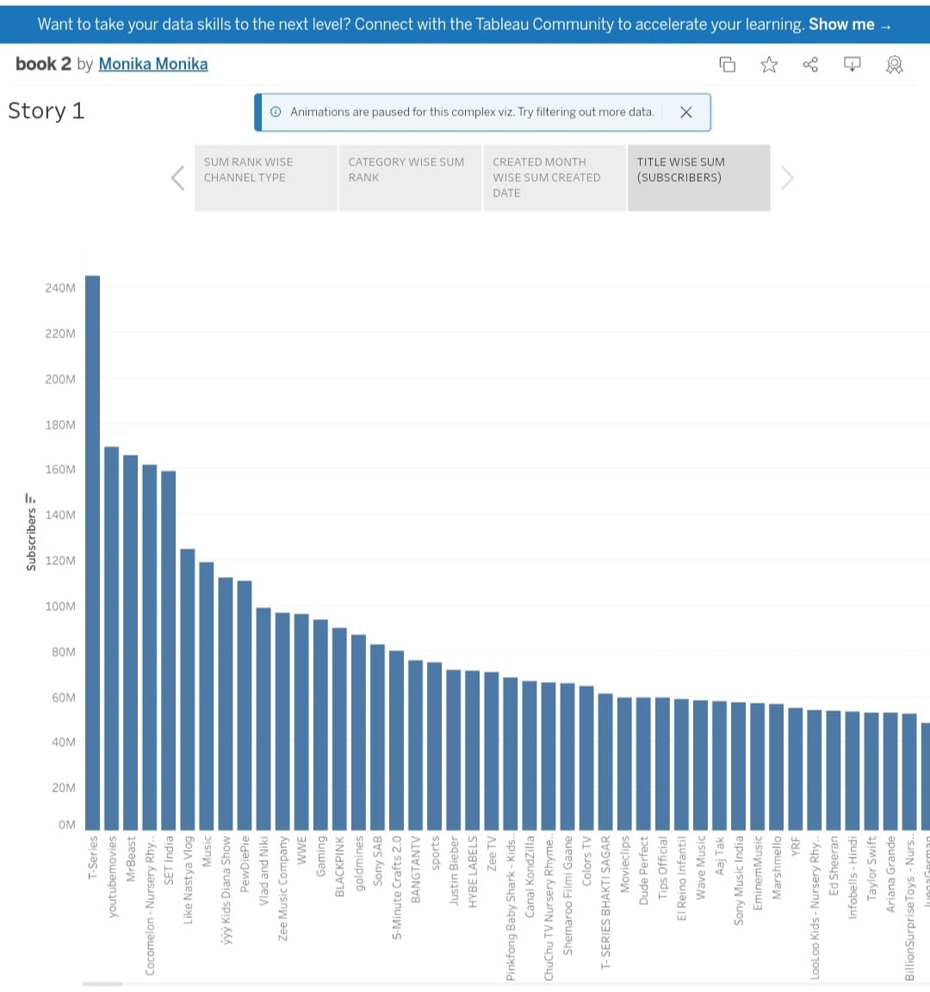

## 4.1 ADVANTAGES:

## 1. Top You Tube channels often have millsions or even billions of subscribers and viewers,allowing them to reach a global audience and have a significant impact.

## 2.They have highly engaged fan bases, which can lead to stronger community.

## 3.They can use their platform to raise awareness about important issues, promote social causes, and contribute positively to society.

## 4.2. DISADVANTAGES:

## 1.There is immense pressure to maintain high-quality content and engagement levels. Any decline in peerformence can lead to a loss of viewership and revenue.

## 2.personal privacy can become a major concern, a fans and the media may intrude into the creator’s personal life, causing stress and discomfort.

## Top chaneenls are often highly dependent on YouTube’s algorithms and recommendations, changes in these algorithms can impact views and income.

## 5.APPLICATION:

## 1.Many yop You Tube channels are focused on entertainment. They create content such as vlogs , comedy sketches , music,videos, and gaming video to entertain and engae their audience.

## 2. Severral top channels, provide educational cotent in various fields, including science, technology,cooking, DIY projecting and more. They serve as valuable resources for lelaring and skill development.

## 6.CONCLUSION:

## In conclusion, the World’s top you Tube channels have a significant impact on the digitial landscape a d global culture.

## They offer a wide range of content, form entertainment and educa tion to advocacy and product promotion.

## These channels enjoy advantages such as masslve reach,monetization opportunities , and creatives freesom, but they also face challenges like privacy incasion,burnout and the need to adapt in a competitive enviuronment.

## 7. FUTURE SCOPE:

## The future scope for the World’s top You Tube chennels will be shaped by technological advancements, shifting audience pregerences, and the evolving digital Landscape.

## Adaptaability,creding , and a strong understanding of their audience will be key factors for continued.